10.00am to 12.00pm. North Muskham Rural Community Centre £4 inc. refreshments [1st two sessions free] Draw, Paint, Doodle - Have a go, gentle support, basic materials supplied. GIVE US A TRY YOU'LL BE WELCOME
Monday Art

Monday Art is the weekly art group based at the Muskham Rural Community Centre, Nelson Lane, North Muskham. We meet each Monday, except Bank Holidays, from 10.00 am till Noon. The group is open to all those interested, whether from North Muskham or the surrounding area.
Background
Monday Art began after a rather short-lived programme of drawing classes came to an end, in 2016. Those classes had rekindled the enjoyment of drawing many of us had at school but, then, life had got in the way. However, it had made us dedicate two hours a week on a Monday morning to grab some 'me time' and enjoy our mutual interest.
After the drawing classes faded, some of us amateur artists wondered what to do, as we had an empty two hours on a Monday morning. Fortunately, that time slot was available at the MRCC. Following discussions with other class members, it was decided to keep the sessions going as a 'self-help' group.

North Muskham Drawing Group was up and running as a small friendly band.

We launched the group officially in 2017, uncertain about how it would go but, instead of the £10 per taught session we started with £6 to cover the two-hour hall costs, refreshments, some materials, and the odd outside adviser if funds allowed. That £6 soon dropped to £4 when we realised we could manage with less. Often, some still life would be set up for members to have a go at drawing and we all shared our thoughts and saw the improvement in our work. Interests began to broaden:
“I’ll try a watercolour.”
"I fancy acrylics.’ and so forth.

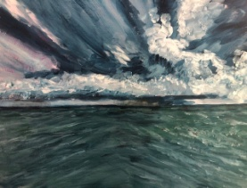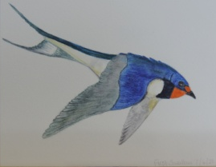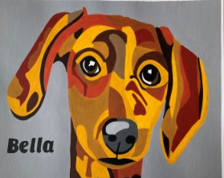
North Muskham Drawing Group, for logical reasons, became North Muskham Art Group. Shock horror! There was a Muskham Art Group, meeting alternate Tuesdays at South Muskham. So, after some discussion within the gang we opted for a clear name of what we were and when we would meet: Monday Art. Although we all think of ourselves as members, and make decisions as a group, we do not have a formal membership, just pay our weekly £4 as we go.

On the first Monday of the month, we have re-introduced a still life for people to have a go at drawing or painting, if they fancy it. This could be a collection of kitchen objects, a flower arrangement, glass and bottle, or anything that comes to mind. Drawing is the essence of virtually any painting, and observation the fundamental of drawing, so it is good to have a go now and again.
The group have a selection of materials for members to try out before investing in their own kit, and there is a small but comprehensive library of books and other guides. More importantly, within the group, there is a growing wealth of experience to encourage, help, and guide as people wish.

Further details from Jim Wishart Tel: 07831183523

